AAMI TIR57 Technical Information Report

AAMI (Association for the Advancement of Medical Instrumentation)

Scope:
This TIR provides guidance for addressing information security within the risk management framework defined by ANSI/AAMI/ISO 14971.
- The TIR57 guidance is thus based on ISO 14971, but the focus is on threat analyses.
- This guidance is intended to assist manufacturers and other users of the standard in the following:
- identifying threats, vulnerabilities, and assets associated with medical devices;
- estimating and evaluating associated security risks;
- controlling security risks; and
- monitoring effectiveness of the risk controls.
- The guidance provided by this document is applicable to all stages of the life-cycle of a medical device.
- it provides a list of steps for how to identify and evaluate threats and vulnerabilities, control security risks, and monitor the efficacy of these controls.
- TIR57 highly focuses on cyber risks.

Structure of AAMI TIR57:2016
The structure of sections 3 to 9 of this document is copied from ISO 14971 standard. It shows how the security risk management process can be modeled in a manner similar to the safety risk management process.
If you’re at ease with ISO 14971, you’ll be at ease with AAMI TIR57. Your effort of understanding will be focused on security risk management concepts, not the process (risk identification, evaluation, mitigation and so on…) that you already know.
We can bless the working group in charge of this TIR for this effort of presentation. The diagram below, extracted from the TIR, shows the analogy between both processes.

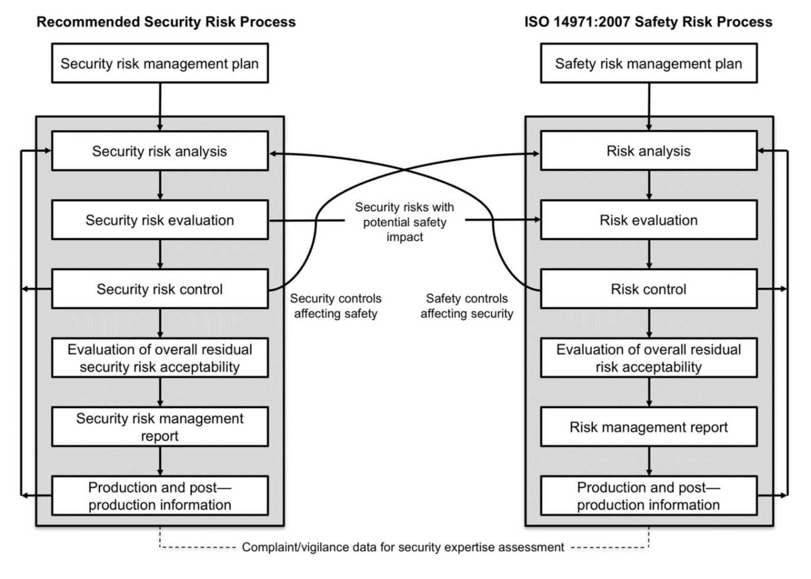

Annexes of AMMI TIR: 57:2016
- The annexes found after section 9 are another wealth of information.
- They contain practical methods to implement a security risk management process.
- There is even a list of questions that can be used to identify medical device security characteristics, like the annex C of ISO 14971 for safety risks!

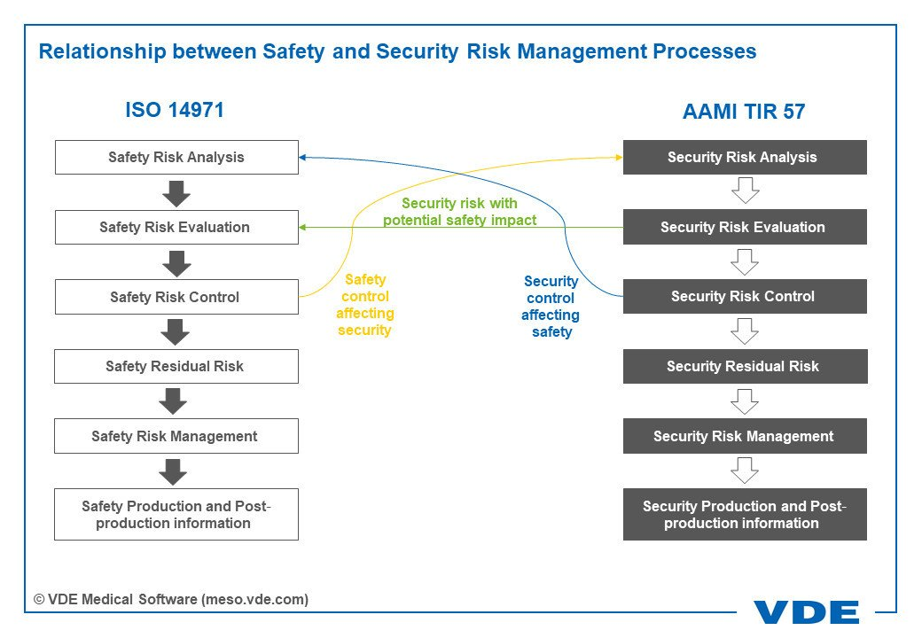
For example:
If an attacker gains unauthorized access to a hospital network, it is a security problem.
If the attacker then influences a networked insulin pump and changes the release of the drug, the security problem becomes a safety problem.
Here are two examples:
- First, a networked infusion pump receives regular software updates as a safety measure. The internal drug library delivers default dosage information to the pump. However, an attacker could gain access to the drug library and change the dosage information. Here, a safety risk control impacts the security risk analysis.
- Second, an intensive care unit uses ventilators. For security reasons, a doctor or a nurse can use a ventilator only if they enter a user name and a password. But what happens in an emergency situation when user name and password are lost? Here, a security risk control obviously affects the safety risk analysis.

REFERENCES
https://journals.sagepub.com/doi/10.1177/1932296818763634
https://standards.globalspec.com/std/14220979/AAMI%20TIR57
https://www.tuvsud.com/en-in/e-ssentials-newsletter/healthcare-and-medical-devices-essentials/e-ssentials-4-2016/protecting-it-systems-aami-report-offers-the-first-dedicated-guide
http://rdcms-aami.s3.amazonaws.com/files/production/public/FileDownloads/BIT/2016_BIT_JF_CybersecurityManufacturers.pdf

